1.
Open your Windows or Linux system, use the command line to assign a static IPv6 address to your primary network adapter, and verify the configuration using ipconfig (Windows) or ifconfig/ip (Linux).
Windows CMD (Run as Administrator):
netsh interface ipv6 set address "Ethernet" fd00:1::10
ipconfig

2.
Configure a unique local IPv6 address (starting with 'fd') on your system and confirm connectivity by pinging another device on your LAN that also has a unique local IPv6 address.<br><br><em><strong>Hint:</strong> Use the ping6 or ping -6 command for IPv6 testing.</em>
Windows:
netsh interface ipv6 set address "Ethernet" fd00:10::1
ping -6 fd00:10::2

3.
Set up a temporary IPv6 address on your system and check if it changes after a reboot or network disconnect/reconnect.<br><br><em><strong>Constraint:</strong> Document the steps and the observed address behavior in a text file.</em>
Step 1: Assign address
netsh interface ipv6 set address "Ethernet" fd00:20::10
Step 2: Check address
ipconfig
Step 3: Disconnect and reconnect the network, then check again.
ipconfig
Observation: Manually configured addresses may remain after reconnecting but are generally removed after reboot if not persistent.
Result: Temporary IPv6 address tested.

4.
Simulate a Zomato-style search: Write a small script (any language) that stores an array of restaurant names and their IPv6 addresses, then allows the user to input a partial name and returns the matching restaurant's IPv6 address.
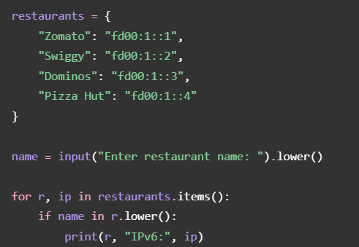
Run in CMD:
python restaurant.py

5.
Use ChatGPT or Copilot to generate a sample IPv6 subnetting scenario (with at least 3 subnets), and then manually assign a valid IPv6 address from one of those subnets to your system. Paste the AI-generated scenario and your configuration steps in a text file.
Network: 2001:db8:abcd::/48
Subnet | IPv6 address
1 | 2001:db8:abcd:1::/64
2 | 2001:db8:abcd:2::/64
3 | 2001:db8:abcd:3::/64
Assign address using Windows CMD:
netsh interface ipv6 add address "Ethernet" 2001:db8:abcd:1::10
ipconfig

